 | 7.0.8 Editors - 3D Viewport - Mesh Object - Texture Paint Mode - Brushes context menus
Table of content
Brushes context menus 1
Radius 1
Size Pressure 1
Use Unified Radius 1
Strength 1
Size Pressure 1
Use Unified Radius 2
Color dialog 2
Blend 2

Brushes context menus
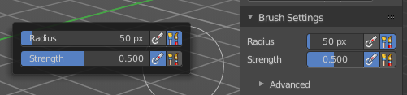
Call this menu with double right click in the 3D viewport. You need to be in Vertex Paint mode with a mesh object.
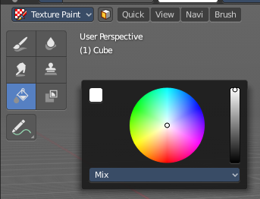
In Vertex Paint mode you will call a context menu with the sliders from the Brush settings
And the fill tool comes with a color dialog.

Radius
The Radius edit box allows you to adjust the radius of the brush.

Size Pressure
The first button behind the edit box enables tablet pressure sensitivity for radius.

Use Unified Radius
The second button behind the edit box enables global radius size. Any modification at the radius will also modify the radius value for other paint tools.

Strength
The Strength edit box allows you to adjust the strength of the brush.

Size Pressure
The first button behind the edit box enables tablet pressure sensitivity for radius.

Use Unified Radius
The second button behind the edit box enables global radius size. Any modification at the radius will also modify the radius value for other paint tools.

Color dialog
Define the color for the fill brush.
Up left is the active color. Change the color in the color dialog.

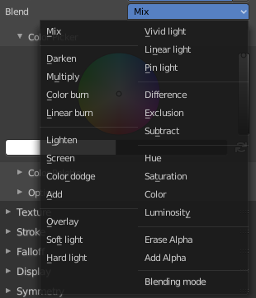
Blend
Define how the stroke will blend. You can choose between various blend modes.

